**Exercises 2.5**

1. **Installed express, uuid, @types/uuid and body-parser via git bash**

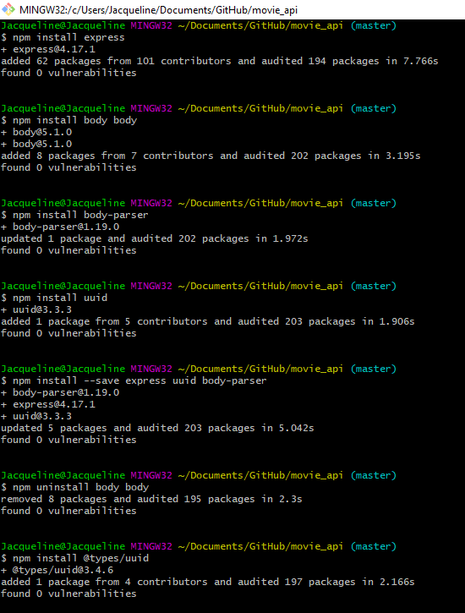

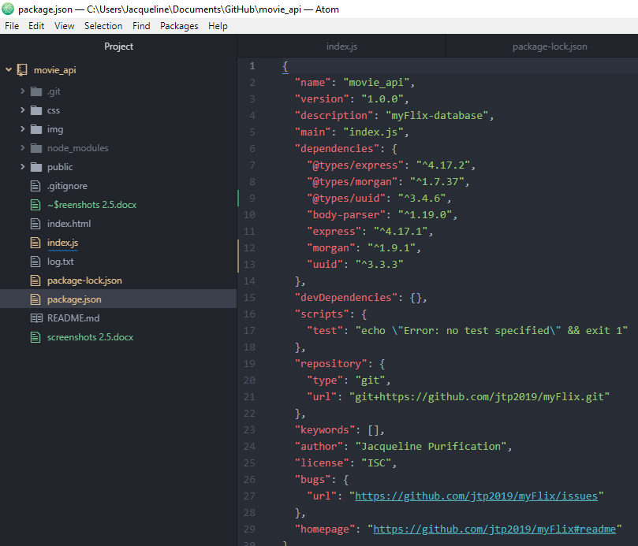

**2) API testing report with git bash**

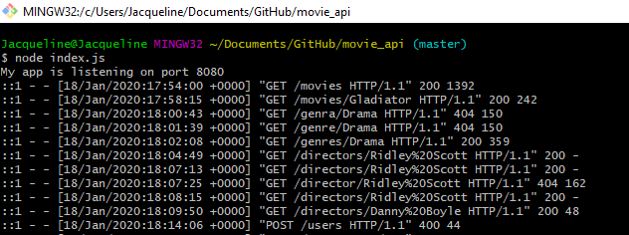

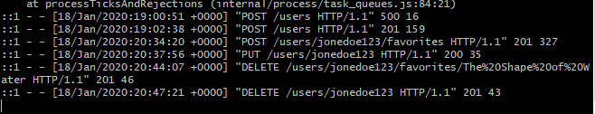

**REST API Testing via Postman**

**Get a list of ALL movies to the user**

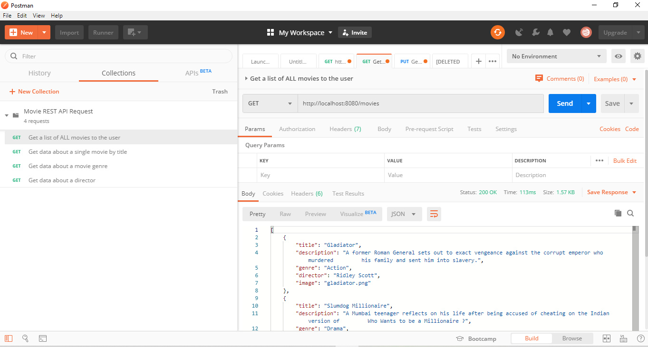

**Get data about a single movie by title**

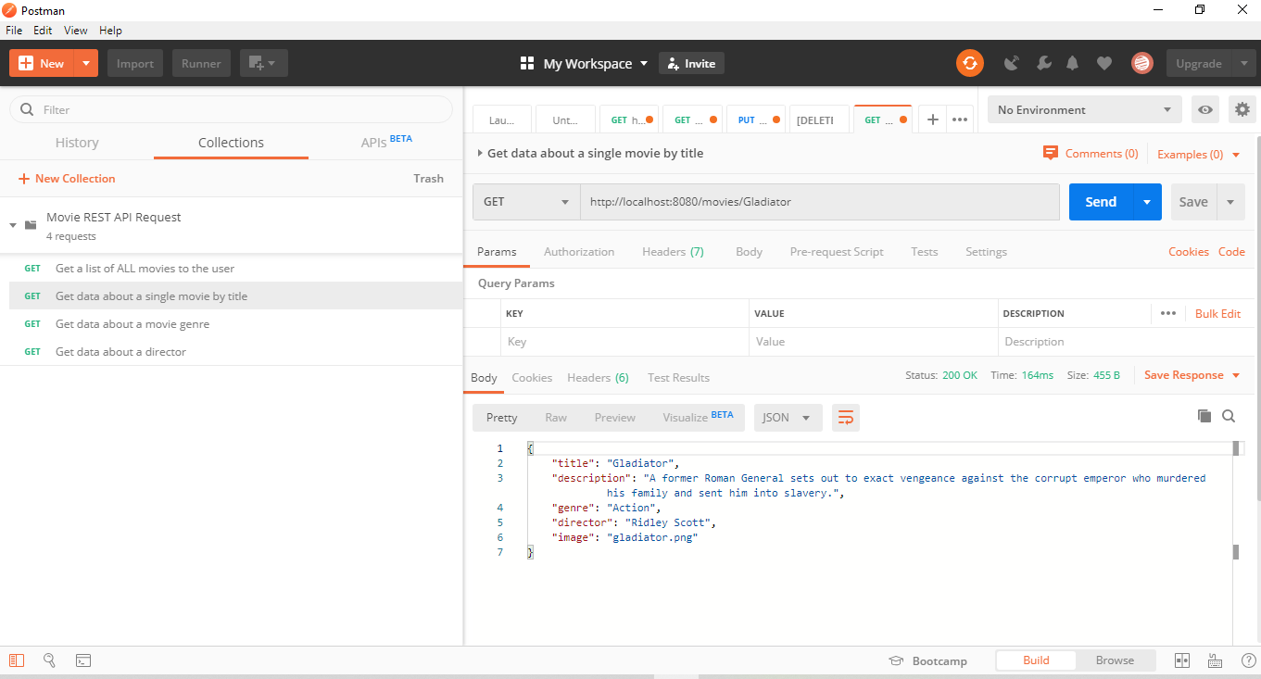

**Get data about a movie genre**

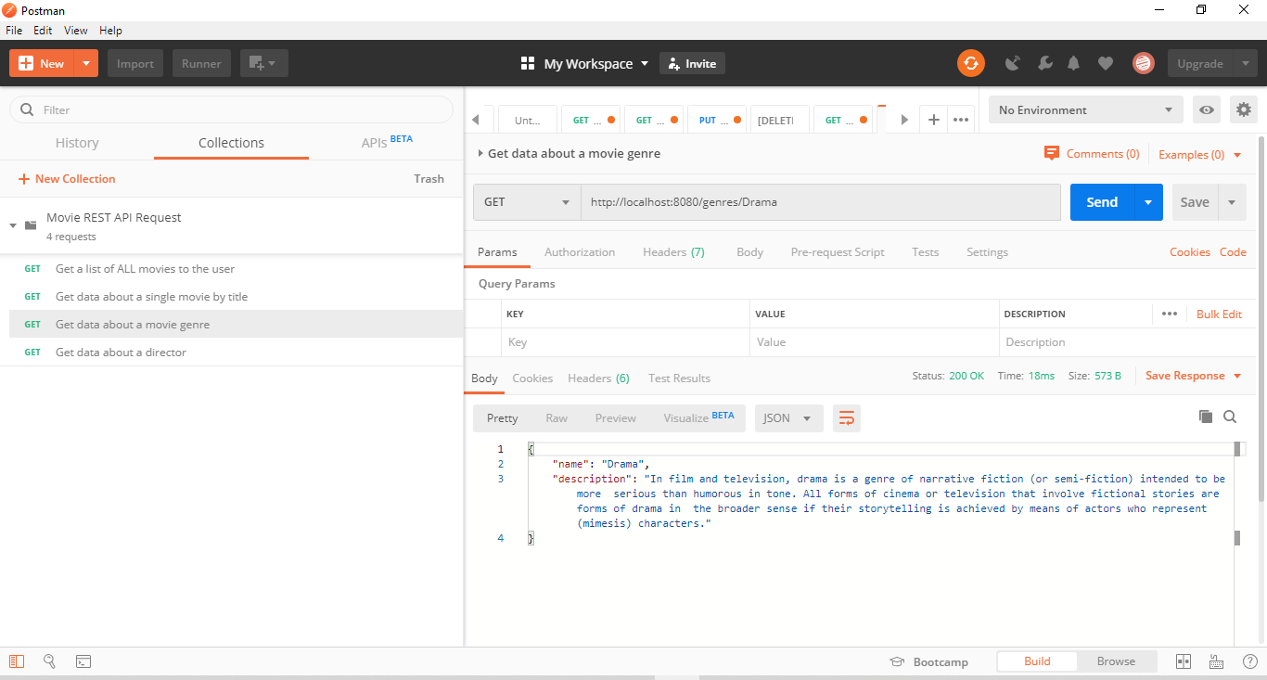

**Get data about a director**

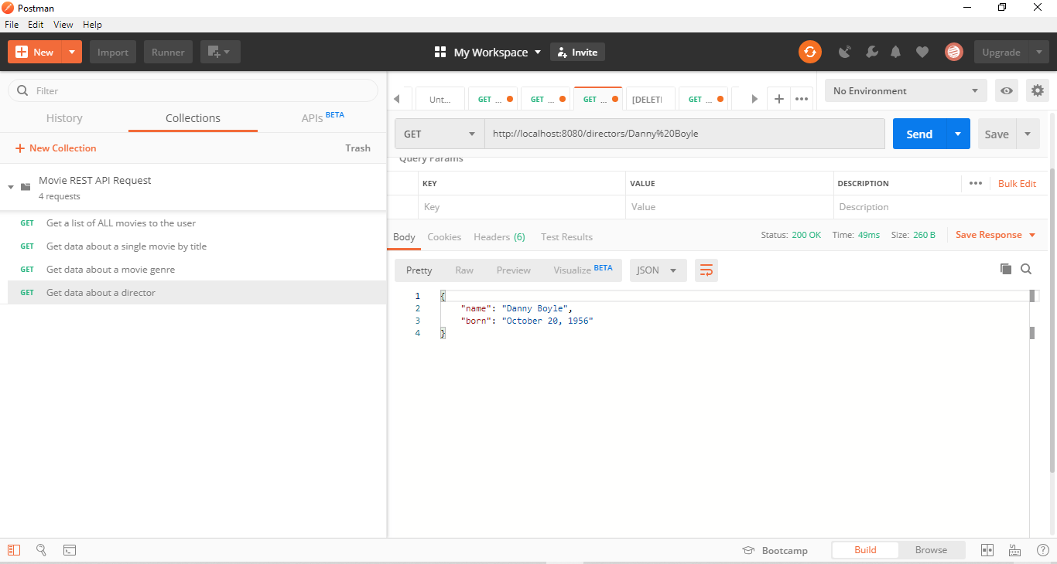

**Add new user accounts**

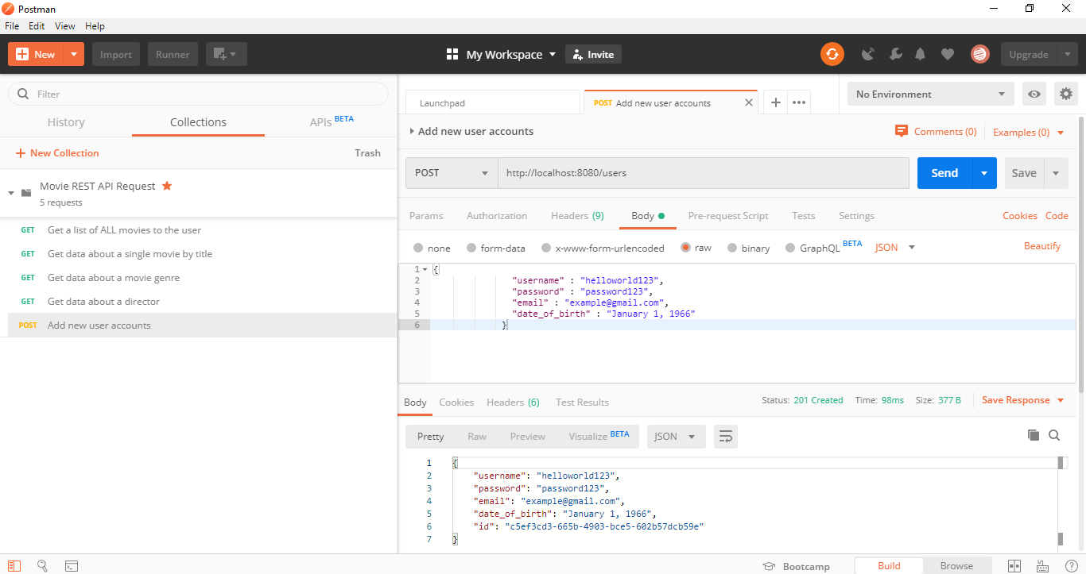

**Add movies to user's list of favorites**

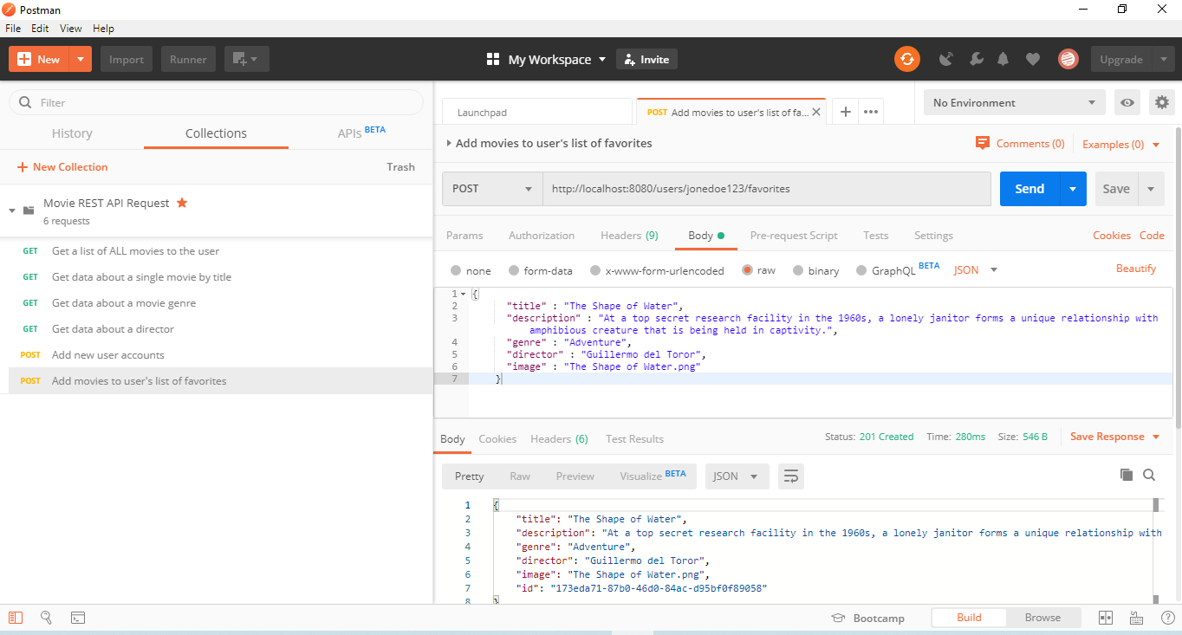

**Update a user's information**

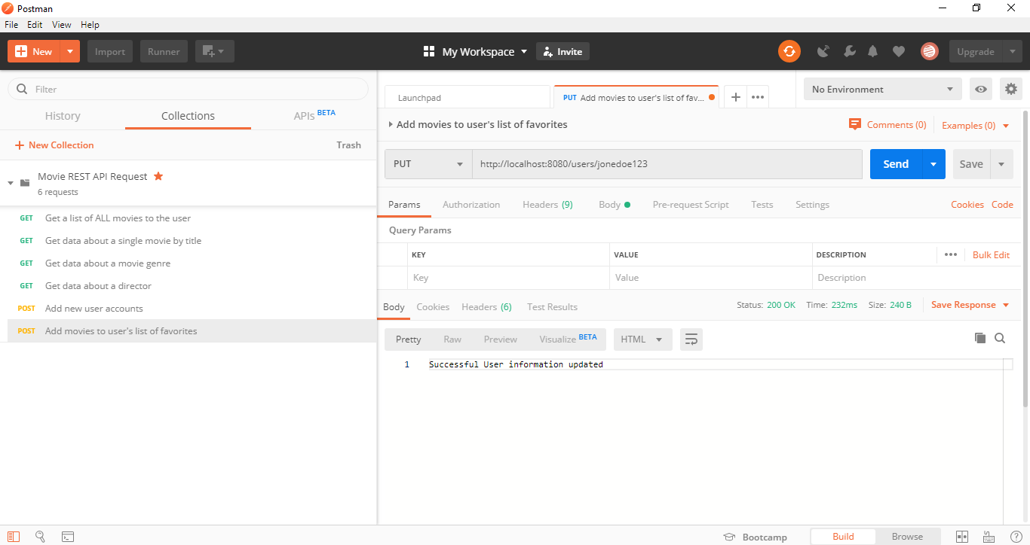

**Remove movies from user's list of favorites**

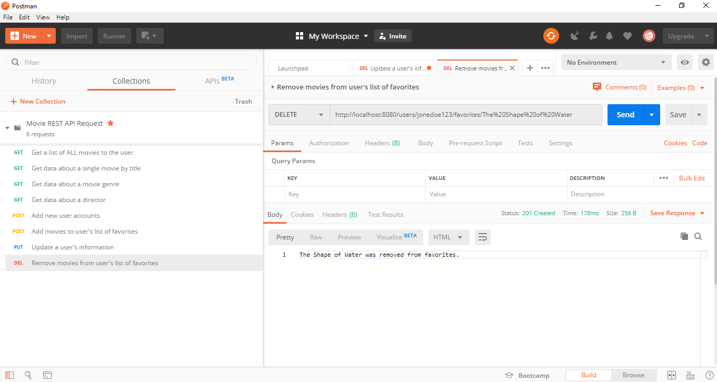

**Remove user accounts**

